2025-05-18

Índice

# Explicación de los datos

Se obtuvieron de diversas fuentes los datos relacionados a la economía nacional de forma trimestral desde el año 2014 hasta el final del año 2024, A continuación se muestra una pequeña muestra de la base de datos.

| **PERIODO** | **PIB** | **TASA_INTERES_PASIVA** | **TASA_INTERES_ACTIVA** | **INFLACION** |
| --- | --- | --- | --- | --- |
| I-2014 | 23,918,828 | 4.530000 | 8.170000 | 0.5092984 |
| II-2014 | 25,028,623 | 4.943333 | 8.000000 | 0.1194710 |
| III-2014 | 25,984,462 | 5.033333 | 8.076667 | 0.4085058 |
| IV-2014 | 27,785,880 | 5.110000 | 8.220000 | 0.1662608 |
| I-2015 | 23,131,951 | 5.283333 | 7.520000 | 0.5388588 |
| II-2015 | 23,909,852 | 5.460000 | 8.413333 | 0.4739387 |

| **IPC** | **TIPO_CAMBIO** | **NIVEL_INVERSION** | **RIESGO_PAIS** |
| --- | --- | --- | --- |
| 146.9530 | 90.69165 | 3,180.459 | 573.53 |
| 148.1347 | 92.96815 | 3,335.978 | 396.21 |
| 149.3273 | 92.87223 | 3,752.165 | 395.56 |
| 150.5839 | 89.88931 | 5,085.778 | 602.72 |
| 101.7920 | 86.29277 | 2,498.280 | 829.93 |
| 103.3984 | 86.59669 | 3,120.740 | 734.85 |

# Exploración de los datos.

A partir de los datos, se obtuvieron las medias, medianas, minimo, maximo, varianza y desviación estandar de cada variable.

| **variables** | **min** | **max** | **media** | **mediana** |
| --- | --- | --- | --- | --- |
| PIB | 21,467,689.5018 | 33,547,596.8328 | 26,866,860.4435 | 26,729,894.7907 |
| TASA INTERES PASIVA | 4.5300 | 8.3567 | 5.8902 | 5.6733 |
| TASA INTERES ACTIVA | 6.9633 | 11.4767 | 8.5510 | 8.4300 |
| INFLACION | -0.4933 | 0.5998 | 0.1110 | 0.0896 |
| IPC | 101.7920 | 150.5839 | 110.6188 | 105.4819 |
| TIPO CAMBIO | 86.0030 | 102.7414 | 92.6426 | 91.6380 |
| NIVEL INVERSION | 1,160.3439 | 5,085.7775 | 2,400.4755 | 2,073.1368 |
| RIESGO PAIS | 395.5600 | 4,208.3781 | 1,087.4076 | 848.9595 |

| **variables** | **desviación** |
| --- | --- |
| PIB | 2,800,494.8260 |
| TASA INTERES PASIVA | 0.9477 |
| TASA INTERES ACTIVA | 0.9656 |
| INFLACION | 0.2250 |
| IPC | 12.5626 |
| TIPO CAMBIO | 4.7997 |
| NIVEL INVERSION | 880.7381 |
| RIESGO PAIS | 670.0656 |

# Mostra los gráficos de dispersión entre variables

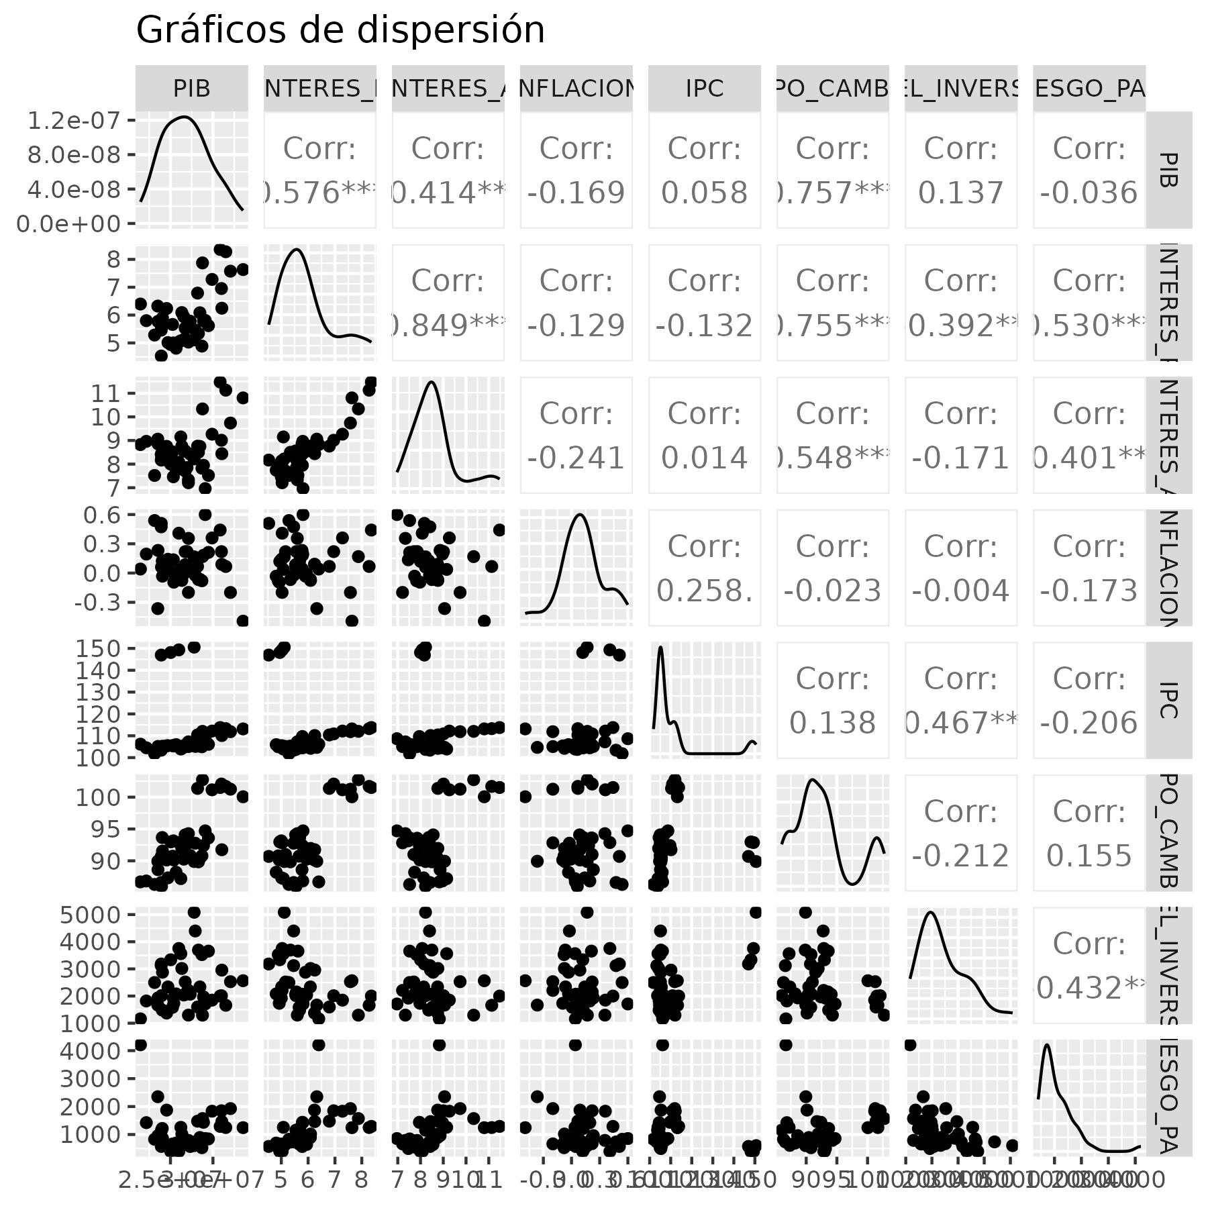

# Modelamiento del modelo para explicar el PIB respecto a todas las variables

Resultados del modelo completo para explicar al PIB

|  | **Estimate** | **Standard Error** | **t value** | **Pr(>|t|)** |  |
| --- | --- | --- | --- | --- | --- |
| (Intercept) | -4,908,626.224 | 6,773,247.076 | -0.725 | 0.4733 |  |
| TASA_INTERES_PASIVA | 2,263,106.209 | 871,790.577 | 2.596 | 0.0136 | * |
| TASA_INTERES_ACTIVA | -1,174,015.527 | 553,895.960 | -2.120 | 0.0410 | * |
| INFLACION | -2,008,688.795 | 1,135,405.006 | -1.769 | 0.0853 | . |
| IPC | -27,163.700 | 24,367.154 | -1.115 | 0.2723 |  |
| TIPO_CAMBIO | 317,010.495 | 96,068.186 | 3.300 | 0.0022 | ** |
| NIVEL_INVERSION | 1,404.440 | 332.960 | 4.218 | 0.0002 | *** |
| RIESGO_PAIS | -945.312 | 478.805 | -1.974 | 0.0561 | . |
| *Signif. codes: 0 <= '***' < 0.001 < '**' < 0.01 < '*' < 0.05* | | | | | |
|  | | | | | |
| *Residual standard error: 1.456e+06 on 36 degrees of freedom* | | | | | |
| *Multiple R-squared: 0.7736, Adjusted R-squared: 0.7296* | | | | | |
| *F-statistic: 17.57 on 36 and 7 DF, p-value: 0.0000* | | | | | |

# Selección del mejor modelo

Mediante el criterio AIC, se determino que el IPC no era significativo para explicar el comportamiento del PIB.

|  | **Estimate** | **Standard Error** | **t value** | **Pr(>|t|)** |  |
| --- | --- | --- | --- | --- | --- |
| (Intercept) | -3,161,403.079 | 6,610,985.533 | -0.478 | 0.6353 |  |
| TASA_INTERES_PASIVA | 2,687,146.170 | 786,996.084 | 3.414 | 0.0016 | ** |
| TASA_INTERES_ACTIVA | -1,408,136.403 | 514,214.390 | -2.738 | 0.0094 | ** |
| INFLACION | -2,510,633.372 | 1,045,719.418 | -2.401 | 0.0215 | * |
| TIPO_CAMBIO | 266,439.666 | 84,959.991 | 3.136 | 0.0033 | ** |
| NIVEL_INVERSION | 1,254.676 | 305.651 | 4.105 | 0.0002 | *** |
| RIESGO_PAIS | -1,080.983 | 464.596 | -2.327 | 0.0256 | * |
| *Signif. codes: 0 <= '***' < 0.001 < '**' < 0.01 < '*' < 0.05* | | | | | |
|  | | | | | |
| *Residual standard error: 1.461e+06 on 37 degrees of freedom* | | | | | |
| *Multiple R-squared: 0.7658, Adjusted R-squared: 0.7278* | | | | | |
| *F-statistic: 20.16 on 37 and 6 DF, p-value: 0.0000* | | | | | |

# Validación del modelo

## Normalidad

Se corrió la prueba de Shapiro-Wilks para probar normalidad:

| **statistic** | **p.value** | **method** |
| --- | --- | --- |
| 1.0 | 0.9474 | Shapiro-Wilk normality test |
| *Signif. codes: 0 <= '***' < 0.001 < '**' < 0.01 < '*' < 0.05* | | |

Se cumple el supuesto de normalidad con un valor de $p=0.9474$.

## Homocedasticidad

| **statistic** | **p.value** | **parameter** | **method** |
| --- | --- | --- | --- |
| 3.8 | 0.7025 | 6.0 | studentized Breusch-Pagan test |
| *Signif. codes: 0 <= '***' < 0.001 < '**' < 0.01 < '*' < 0.05* | | | |

Se cumple el supuesto de homocedasticidad con un valor de $p=0.7025$.

## Independencia

| **statistic** | **p.value** | **method** | **alternative** |
| --- | --- | --- | --- |
| 1.4 | 0.0046 ** | Durbin-Watson test | true autocorrelation is greater than 0 |
| *Signif. codes: 0 <= '***' < 0.001 < '**' < 0.01 < '*' < 0.05* | | | |

NO se cumple el supuesto de independencia en el modelo, con un valor de $p=0.0046$.

# Verificar la inflación de la varianza y problemas de multicolinealidad.

| **VIFF** |
| --- |
| 11.204142 |
| 4.965714 |
| 1.114972 |
| 3.349415 |
| 1.459660 |
| 1.952050 |

Los valores para el factor de inflaciń de la varianza se encuentran dentro de los valores aceptables.